- Interacting with Active Directory
  - .NET Framework
    - Leverages the System.DirectoryServices.DirectoryEntry Class
  - ADSI Accelerator
    - A wrapper that was placed around the system.directoryservices.directoryentry class providing a similar look and feel to the old vbscript provider
    - Using .psbase strips away the wrapper
    - Does not work well with Get-Member
  - Active Directory Module
    - 76 Available Cmdlets
    - Introduced with Windows 2008 R2
- 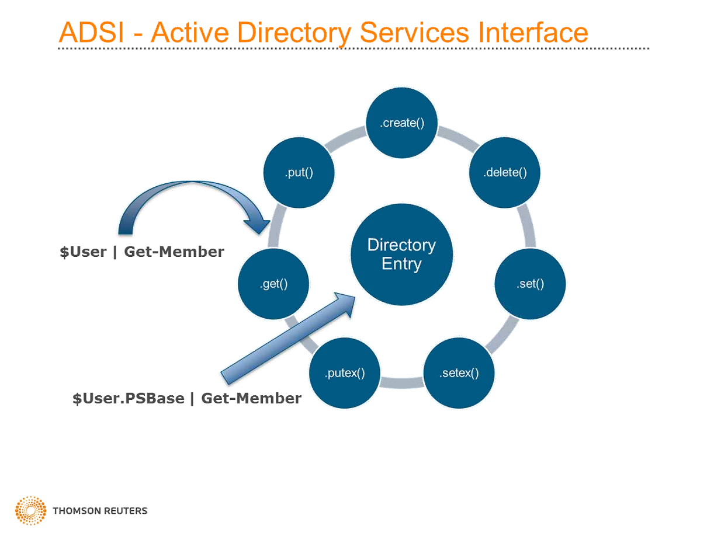

- Active Directory Web Service
  - Installed with the AD DS or AD LDS roles
  - Active Directory cmdlets rely on the ADWS service
  - TCP Port 9389
- Active Directory Management gateway service
  - Allows PowerShell cmdlets to be used against windows 2003 and 2008
- AD PowerShell module is installed by installing the RSAT toolkit
- 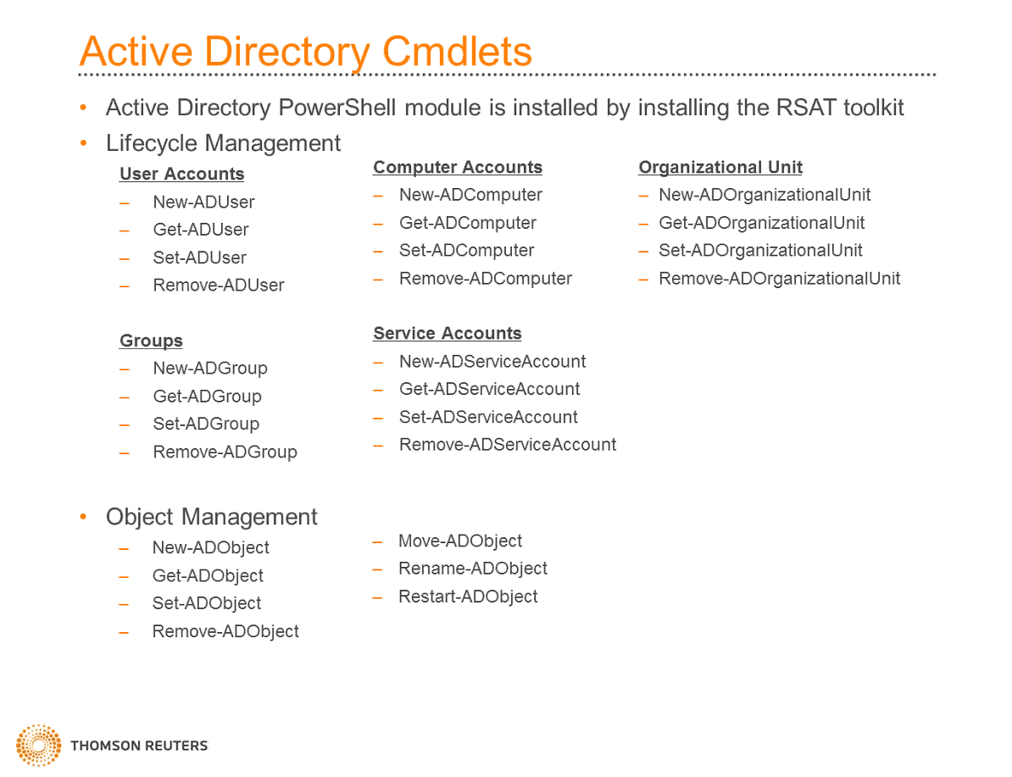
- Active Directory Provider
  - Adds an additional provider to PowerShell named AD:
  - Allows you to create, manage, and remove AD objects
- Creating AD Objects
  - New-ADUser
    - Creates a new Active Directory User
    - Key Parameters
      - Name – Name of user
      - Path – Path of OU you’d like the object created in
      - Credential – Impersonate across security boundaries
      - DisplayName – Specifies the display name of the user
      - SamAccountName – Specifies the samAccountName of the user
        - Login username
      - Server – Domain Controller to connect
    - New-ADUser –Name User1 –Path “OU=Managed-Users,DC=powershell,DC=local”
    - Get-ADUser User1
  - Set-ADUser
    - Modifies an AD user object
      - Identity – Name of User
      - Server – Domain Controller to connect
    - Set-ADUser –Identity User1 –Title “Engineer
  - Remove-ADUser
    - Removes an Active Directory
    - Parameters
      - Identity – Name of User
      - Credential - Provides the ability to impersonate
      - Server – Domain Controller to connect
      - Confirm – Prompts to continue
- Example Script
#prepare Enviornment

clear-host

#define Destination OU
$OUPath = "OU-Managed-Servers,dc=powershell,dc=local"

#Get File Content
$Users = Import-CSV -Path c:\Training\Users.txt

#Process content and output results

foreach ($User in $Users) {
try {
New-ADUser -Name $User.UserAccount -DisplayName $User.DisplayName -Path $OUPath
Write-Host “Successfully Created” $User.UserAccount –ForegroundColor Green
}
Catch {
Write-Host “User Creation FAILED for user” $User.UserAccount _ForegroundColor Red
}
Finally {

}

- Resources
  - 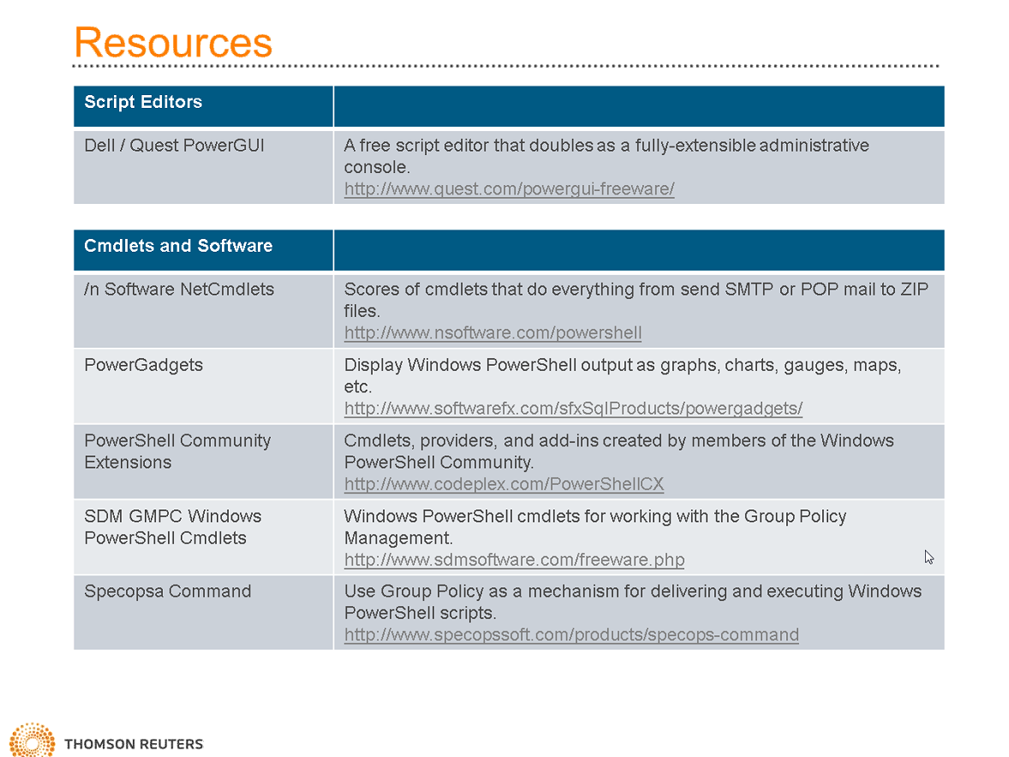
- Books

 